Hello, we are Team 13 and we are participating in version 4.0 of the Data Science for all program. The team members are:

Raúl Cantillo, Ingrid Cortes, Jerson Felipe Guerrero, Aura Paola Pai, Ignacio Perez and John Ramírez.

(wait while the video starts)

Hi John!! Grandma passed away, I was her favorite grandson and she left me her money, Grandma only believed in bank accounts and now I have $ 2,500,000. Now I will able to travel or buy that red Porsche that I dreamed of as a child…. Or… rather I will find some interesting investment, I will have a monthly income and I can start to think about how to develop my home for orphaned kittens.

In my family they have always said that the real estate is good, that land and properties do not vanish …. I already invested in Lisbon. Look what was in the newspaper:

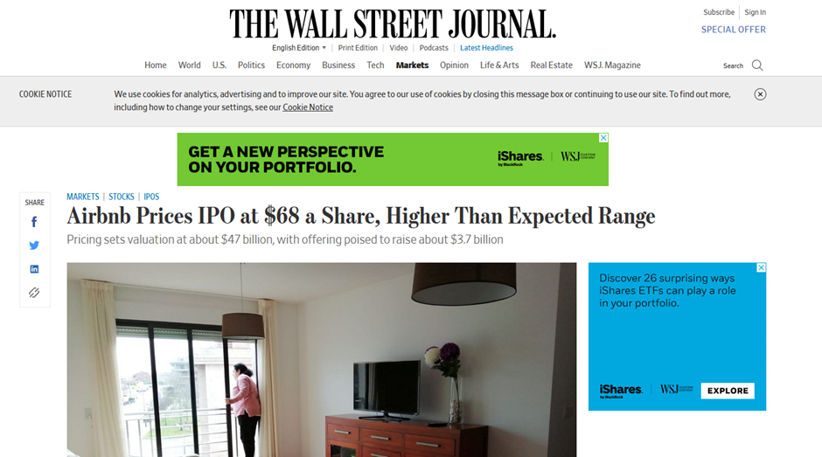

AirBnB, went public, they exceeded the expectations of what they were aiming at, Airbnb’s stock opened at $146 per share Thursday — more than double the figure the company set for its Initial Public Offering the night before!. Do you know that I invested in Lisbon? In the center of the city a lot of buildings have been refurbished, and they are now beign offered on the AirBnB platform, on the first floor there are automatic food machines, the apartments are cleaned every third day, this is a new type of hotel ...

You are right. In this post Covid People will want to be able to travel without having to share with other people. A home to rent on AirBnB can be a good idea… how much will a property rent?

The other day I saw an interesting company ... where is it ... Here it is! Invest-Air, as it says in the mail is a new company, which has done analysis of a lot of AirBnB data, they have analyzed prices per night, they have studied how the occupancy of the properties is to understand how much it will rent, they have studied the types and characteristics of different types of properties on AirBnB, they have developed machine learning models to establish the price of a home by looking at the things that people are interested in when they rent, like the number of rooms, or if it has enough bathrooms, how many people can fit ...

Let's see how it works….

Here you can input the amount of money you have, it’ll show you, by cities, actual AirBnB properties within that range, Let’s see New York

Here you see, in New York, the zip codes and their mean income which depends on the price they charge per night and the occupancy rate. If you hover over an area you can see the average price they charge per night and the average number of bedrooms of the properties in that zipcode.

This one looks interesting….

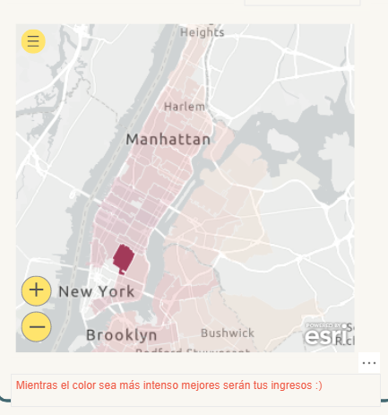 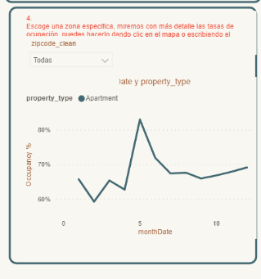

I like apartments are they interesting?, they do not show such a good occupancy rate….

Here you can see the detail… Summer looks interesting…. How are the properties there?... Look!, a monthly income of $150.000? and an occupancy rate of 68%.

I like it … I can use it also for my trips to New York.. There are a good number of them with 2 rooms, I can close one and Keep it for myself… I like the idea, We are going next week end to take a closer look at this area of ​​New York so as not to waste time investing my money ...

Closing